**“E-Recruit: An Online Recruitment System**

**for Insurance and Investment Agency**

**in MIMAROPA”**

A Research/Capstone Project

Presented to the Faculty of the

College of Computer Studies

**MINDORO STATE UNIVERSITY**

Calapan City Campus

Masipit, Calapan City, Oriental Mindoro

In Partial Fulfillment

of the Requirements for the Degree

**BACHELOR OF SCIENCE IN INFORMATION TECHNOLOGY**

Caibal, Lester M.

Escalera, Jandel L.

Ramos, Jef

November 2023

**TABLE OF CONTENTS**

|  |  |  |  |
| --- | --- | --- | --- |
| **I. INTRODUCTION** | | |  |
|  | **Project Context ……………………………………………………………………………** | | **1** |
|  | **Objectives of the Study ………………………………………………………** | | **2** |
|  | **Scope and Limitations of the Study …………………………** | | **4** |
|  | **Significance of the Study …………………………………………………** | | **4** |
|  | **Conceptual Framework ………………………………………………………………** | | **6** |
|  | **Definition of Terms …………………………………………………………………** | | **6** |
| **II. REVIEW OF RELATED LITERATURE/ SYSTEM** | | |  |
|  | **Local ………………………………………………………………………………………………………** | | **11** |
|  | **Foreign …………………………………………………………………………………………………** | | **19** |
| **III. METHODOLOGY** | | |  |
|  | Development Method **……………………………………………………………………** | | **24** |
|  | Gantt Chart **………………………………………………………………………………………** | | **27** |
|  | Requirements Specifications **……………………………………………** | | **29** |
|  |  | Functional Requirements **……………………………………………** | **29** |
|  |  | User Interface **……………………………………………………………………** | **31** |
|  |  | Hardware Interface **…………………………………………………………** | **32** |
|  |  | Software Interface **…………………………………………………………** | **32** |
|  |  | Security Requirements **…………………………………………………** | **33** |
|  | Technical Background **………………………………………………………………** | | **33** |
|  |  | Hardware Specifications **……………………………………………** | **34** |
|  |  | Software Specifications **……………………………………………** | **34** |
|  | System Analysis and Design **…………………………………………………** | | **35** |
|  |  | System Overview **……………………………………………………………………** | **36** |
|  |  | System Architecture **…………………………………………………………** | **37** |
|  | Use Case Diagram **……………………………………………………………………………** | | **38** |
|  | Activity Diagram **……………………………………………………………………………** | | **40** |
|  | Data Flow Diagram (DFD) **…………………………………………………………** | | **41** |
|  |  | Context Diagram/Level 0 **………………………………………………** | **41** |
|  |  | Diagram 0/Level 1 **………………………………………………………………** | **42** |
|  | Database Schema **………………………………………………………………………………** | | **43** |
|  | Testing and Evaluation **……………………………………………………………** | | **44** |
|  | Implementation Plan **……………………………………………………………………** | | **46** |
|  |  |  |  |
|  |  |  |  |
|  |  |  |  |

**CHAPTER 1**

**INTRODUCTION**

This chapter will address priority things of the study which should be considered properly for implementing it successfully.

**Project Context**

Industries are always being transformed and remodeled by digital technology. Society is greatly affected since it shapes the way individuals get information, relate to one another and how people operate in this society. Research study criticality in terms of doing the research involves requesting and gather information from the users directly. The research problem chosen is supported by the project context thus demonstrating that the researcher can handle challenges involved with it. For example, difficulties associated with handling paper-based documents have been pointed out. Researchers mention problems including risks involved such as inconvenience that arises when visiting applicants’ homes to collect their personal details among others that make recruitment processes more complicated. An Online Recruitment System for Insurance and Investment Agency in MIMAROPA is intended to address certain challenges identified within the local setting.

The title’s choice is due to the problems noted with managing paper-based documents in the recruitment process. The main concern is that handling hard copy documents is complicated and unsafe thereby necessitating people to visit other homes for essential information. In recruiting, making the process modern is good for improving productivity and having a less risks or problems. Opting for an online recruitment system presupposes attempts aimed at conforming actual employment search strategies with current industry requirements. This method increases productivity while satisfying contemporary needs thereby enhancing the reputation of a company or organization as well. Focusing on MIMAROPA makes it a locally fashioned tool which can be customized to serve specific needs and peculiarities within this locality. There were various factors evaluated before designing and implementing an Online Recruitment System, which include geographical distance problems, insecure paper-based procedures, no good services specifically designed to improve clients’ experiences as well as customer satisfaction among others It assures stakeholders that they will not encounter any difficulties in using this technology because it mainly focuses on them rather than other systems that only have a general purpose.

**Objectives**

The goal of the study is to establish an online recruitment system that will augment the agency placement for insurance and investment representatives in MIMAROPA, assist the employers and applicants of MIMAROPA to ease their transactions as well as expedite it quickly.

Specifically, this study is intended to:

1. Implement an online platform for agent and applications that accepts electronic forms and signatures.
2. Provide applicants a simple option of accessing the forms through online and resources, and make changes in agent process.
3. Create ease of use for the applicant by giving them an intuitively designed platform for application.
4. Make a database of potential agents and applicants for the insurance and investment agency.
5. Ensure the system follows the data protection and recruitment regulations.

**Scope and Limitations of the Study**

Understanding the pros and cons, the choice has been made to focus as a study on the online recruitment system of insurance and investments company in MIMAROPA Philippines, as the major study field. An online recruitment system offers an active strategy to modernize the operations into recruiting agents, which is the most useful in business life. The study's focus on MIMAROPA recognizes the significance of system customization to the local specifics, guaranteeing that the solution is not only standardized but also in line with the complexities of the regional insurance and investment landscape.

The study seeks to improve the efficiency of the process by the three user roles which are administrators, agents, and applicants. Administrators are important individuals who supervise the entire recruiting workflow since they have the authority to add or register applicants and use the system for recruitment. Agents engage with the system in a targeted way, concentrating on their unique contributions to the recruiting part, thanks to the purposeful restriction of their access to the recruitment. The purpose, however, is to improve on the experience applicants have by letting them view requirements, submit and at the same time, modify their background data using the online platform. This promotes a dynamic and user-friendly application process.

**Significance of the study**

**Applicants -** The online recruitment system is a porta; that helps the applicants in a lot of ways. The application/website will be accessible to the applicants or job seekers that will be easy for them to use. This opens up a new and easier way in recruiting applicants.

**Insurance and Investment Agencies -** Recruiting new applicants will be processed more easily, thanks to the system. It will also be more efficient which will be useful for the company. It increases the competitiveness of the agency in the market. This could result to a more successful business.

**IT Experts -** IT professionals/experts that are working on the same kind of system will have a hands-on experience in developing a platform where it is only for online recruitments.

**Business Professionals -** Professionals in business management might have a lot of opportunities using the system as basis, they can have new tactical strategies for their businesses in effectively and efficiently hiring applicants.

**Clients -** Clients benefit from the system by being notified by their transactions and important information on their accounts. They could also view their history transactions.

**Researchers -** The developers of the E-Recruit and also the programmers will get a ton of experience and credibility on them. They will have gain not just experience but also possible opportunities on their successful system.

**Future Researchers -** E-Recruitment Agency System can serve as a reference that will help who are researchers working on the same platform. It also offers a lot of usable ideas and example of successful implementation and how it became successful in the investment and insurance sectors.

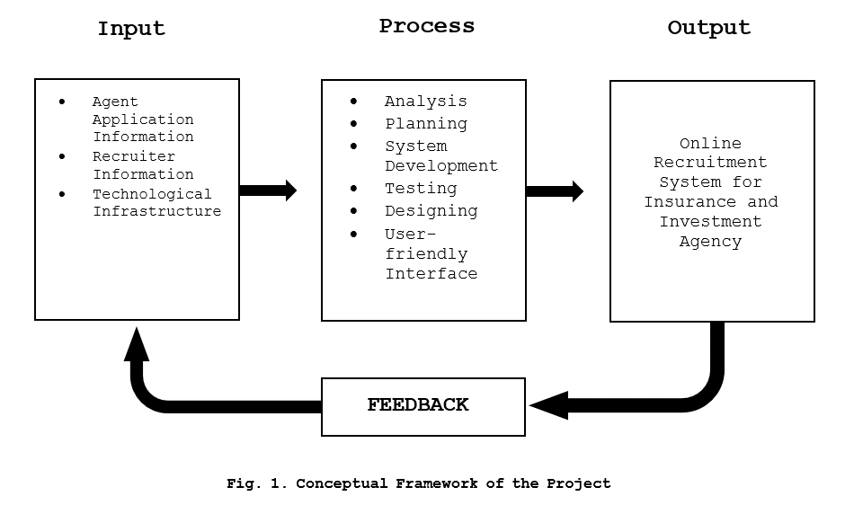**Concept of the Study**

**Figure 1. Conceptual Framework of the Project**

Figure 1, represents the relationships and sequences between these elements, showing how the input is processed through various stages to produce the desired output, which is the Online Recruitment System for the specified agency.

**Definition of Terms**

To facilitate clarity, researcher break down the following terms:

**Metrics** - is a quantifiable measure used to assess and analyze the performance and effectiveness of the Online Recruitment System.

**Niche** - is the specific skill set or job market focus of the Online Recruitment System.

**Digital Technology** - is the utilization of electronic devices, software, and online resources to facilitate, and enhance various processes within the Online Recruitment System.

**Recruitment System** - is an integrated set of processes, tools, and technologies designed to manage and optimize the recruitment process.

**Overshooting** - is the situation where the number of applicants exceeds the available positions.

**Toolset** - is a collection of software tools and applications integrated into the Online Recruitment System to perform various tasks such as applicant tracking and evaluation.

**Social Media** - is utilized for postings, employer branding, and reaching potential applicants through platforms like Twitter, and Facebook.

**Data-Backed Hiring** - relies on the analysis of data and metrics to make informed decisions throughout the hiring process.

**Online Platform** - is a web-based interface or application that facilitates various recruitment activities, including application submission, communication between agents and applicants, and the management of the hiring workflow.

**Electronic Forms** - is a digital document that replace traditional paper-based forms in the recruitment process.

**Database** - is structured collection of data stored electronically, candidate profiles, and other relevant details.

**CHAPTER 2**

**REVIEW OF RELATED LITERATURES**

This chapter presents the review of related literature that provides the researchers a strong foundation for the study.

**Local**

The paper proposes an automated Online Job Finder system using Microsoft Access (MS Access) for fresh graduates, unemployed individuals, and companies in the Philippines. The system allows applicants to input their details conveniently, upload their information, and automatically match them with suitable companies based on their preferences. It also enables applicants to verify the authenticity of the company. The database system aims to provide a more efficient and convenient way for both job seekers and companies to find suitable matches, especially during the pandemic and with the advancement of technology. (Dela Paz et al., 2020)

The study explores the adoption of E-recruitment in human resource management, focusing on the Z generation. E-recruitment is a web-based HR software that assists in the hiring process, reducing financial burdens and improving administrative efficiency. The data was collected from 230 respondents and analyzed using the PLS structure equation model. The results showed that the expectation of positive results affects E-recruitment retrieval. The findings offer valuable insights into E-recruitment's implications in the era of Industry 4.0.(Grimaldo et al., 2020)

In the context of the industry technological revolution, organizations are swiftly embracing digital trends, with E-recruitment emerging as a notable innovation in human resource management. E-recruitment, a web-based HR software, leverages technology to enhance the hiring process, aiming to reduce financial burdens, improve administrative efficiency, and access a broader talent pool. This study collected 230 data points from purposively selected Generation Z respondents and employed the PLS structural equation model to assess the adoption of E-recruitment technology by this demographic. The results indicate that positive expectations significantly impact the adoption of E-recruitment. The findings offer valuable insights and recommendations, shedding light on the implications of E-recruitment in the contemporary era of Industry. (Jayabalan et al., 2019)

This chapter examines the role of Information and Communication Technology (ICT) in employee recruitment and selection during the COVID-19 pandemic. It highlights the importance of online platforms, identifies challenges, and suggests strategies for improvement. Strategies include enhancing data privacy, utilizing business intelligence, adopting work-from-home arrangements, and integrating ICT into post-pandemic operations. (Jalagat & Aquino, 2022)

The article highlights the importance of recruitment in today's competitive labor market and the rise of E-recruitment, which allows companies to post job opportunities online, receive resumes, and engage with applicants via email. Key success factors include value-added services, cost-effectiveness, speed, customized solutions, relationship-building with human resources managers, and promotion of corporate branding. However, the article acknowledges its limitations and disadvantages, using case studies to analyze the pros and cons of E-recruitment and its growing significance in company recruitment processes. (Kruteeka & Monica, 2018)

The increasing use of Artificial Intelligence (AI) in recruitment is transforming the recruitment process, but the perception of AI from the candidate's perspective is limited. This study investigates applicants' experiences and perceptions of AI-enabled recruitment. Results show that applicants perceive AI technology positively in hiring processes, with reduced response time being the most significant benefit. However, the biggest drawbacks of AI in recruitment include lack of nuance in human judgment, low accuracy and reliability, and immature technology. (Automation in Recruitment: A New Frontier, 2018)

Monroe Consulting Group hosted a webinar on Recruitment: New Normal, discussing the recruitment market landscape in the Philippines. The event, attended by 100 participants, discussed the impact of the pandemic on businesses and the need for a proactive approach. The webinar discussed industries thriving during the pandemic, such as e-commerce, online education, and financial technology, and sectors recovering from the pandemic. The webinar also highlighted the benefits of digital recruitment, including fewer interview rounds and a larger talent pool. Speakers included Jennifer Tan, Maria Ysabel Bordador, Ismael Fisco, James Allan To, and Mario Glenn Isic. (The New Normal: The Philippines Recruitment Market | Monroe Consulting Group, 2020)

Online recruitment activity in the Philippines is expected to remain positive for the rest of the year due to favorable economic conditions, according to employment website Monster.com. The Philippines has seen a spike in hiring activity at the start of the year, partly due to the positive investor outlook on the country's macroeconomic fundamentals. The inflow of foreign direct investments (FDIs) has allowed businesses to expand and create job opportunities. The move of businesses and organizations to take advantage of opportunities using digital technologies is also expected to drive online hiring activity. The Philippines is expected to witness an increase in its gross domestic product by $8 billion due to digital transformation. (Online Recruitment Seen to Remain Positive, 2018)

E-hiring sentiment in the Philippines increased in Q4 due to economic recovery, with strong growth numbers of 15%, 15%, and 14% year-on-year for October, November, and December. IT, Telecom/ISP, and BFSI sectors led the growth, with HR & Admin professionals leading the way. The Monster Employment Index (MEI) shows HR & Admin professionals led annual growth in online demand, while Finance & Accounts talent experienced surging demand. (Intelligence: Online Hiring in Philippines Increases Fifteen Percent in 2019 Q4, Shows Study by Job Search Platform Monster, 2019)

Recruitment agencies are becoming increasingly essential for companies looking to hire the right employees. With their extensive network and experience, they can efficiently filter and choose candidates, saving time and resources. Recruitment agencies also offer exclusive access to job openings and can assist job seekers in finding their ideal jobs. They can help applicants through online platforms or by forming partnerships with their clients. They also help companies find suitable positions for their employees, ensuring they become top performers. Hiring recruitment agencies also saves companies from costs associated with the hiring process, such as pre-employment testing, drug screening, and background investigations. This allows companies to focus on other important aspects of their businesses. (Importance of Recruitment Agencies, 2023)

The pandemic has led to a shift from face-to-face interviews to virtual ones, causing concern among companies. In May 2020, Philippines government urged companies to conduct virtual interviews using video conferencing and Skype. Online recruitment uses digital technology to virtualize hiring processes. In August 2020, 9 out of 10 Filipino employers laid off staff, resulting in 13% needing to hire new people. Employers must stay updated on digital trends and match suitable candidates for company growth. (Normalising E-recruitment and Why You Should Join the Trend, Now, 2023)

Employment recruitment in the Philippines is allegedly collusion between recruitment agencies and lenders, resulting in high recruitment fees and predatory lending. Authorities are failing to address this issue, despite numerous complaints. (Philippines: Recruitment Agencies and Lenders Allegedly Collude to Exploit Migrant Workers, Amid Lack of Govt. Action to Tackle Abuse, 2023)

**Foreign**

Based on the study of (Bhosale et al., 2021), it examines the prevalence of electronic recruitment in HR professionals' practices. It discusses the evaluation of e-recruitment for organizational growth and the sourcing of the right candidates at the right time and cost. This study explores the positive effects of online recruitment on organizations and its impact on finding eligible candidates.

The development of a Smart Recruitment System using machine learning algorithms for an organization to attract potential and talented candidates. The system aims to save time the recruitment process (Shendage et al., 2019).

As explained by (Hotwani et al., 2019), it examined informal and formal recruiting practices in external labor markets and found that quality was a stronger motivator than cost for informal recruiting. It focused on e-recruitment and highlighted that internet platforms, such as career websites, could be a cost-effective alternative to multiple newspaper ads for small companies.

Ramadhani et al. (2019) underscores the importance of recruitment for organizations and posit that web development can enhance efficiency and speed in the recruitment process while reducing costs.

Blumenberg et al. (2019) echo the logistical advantages, citing the ease of placing ads on websites or sending automatic messages over the internet.

As determined by (Hashiyana et al., 2021), he note the utilization of internet-based recruitment methods by some companies, emphasizing the need for a proper understanding to avoid errors. The review concludes that online recruitment is an effective and innovative method for hiring, providing a faster and more efficient approach to collecting human resources for organizations.

Lee et al. (2021) highlights the role of recruitment agencies as intermediaries connecting companies with potential applicants, conducting remote interviews and assessments.

In the opinion of (Ho and Henry, 2021), stress the security advantages of a portal exclusive to applicants scouted by employers, addressing concerns related to fraudulent activities in online portals. The logistical simplicity of online recruitment methods, as compared to offline methods, is emphasized by Ho and Henry (2021).

Based on the study of (Prasetyaningtyas et al. ,2022), it emphasizes the challenges in the traditional recruitment process, citing the abundance of labor involved. The introduction of online systems is presented as a solution, simplifying the process for both employers and applicants.

Moseson et al. (2020) discusses the substantial benefits of virtual recruitment in the context of technological advancements, allowing hospitality organizations to rely on digital efforts for applicant attraction.

Karaoglu et al. (2022) highlight the impact of sociodemographic factors, such as age, race, education, and income, on online job searching. Acknowledging the disparities, the review suggests that online recruitment techniques should consider these inequalities to promote diversity.

As stated by (Aljuaid, 2021), he discusses the contribution of an AI-based e-recruitment system that can assess the experience, qualifications, and suitability of candidates applying for specific jobs. It emphasizes the need for efficient recruitment strategies to recruit employees with high potential and execute talent management strategies.

Malki and Atlam (2021) argue that applying to companies using traditional paper forms is ineffective, contributing to the development of online recruitment systems.

As stated by (Chuks et al., 2019), he discusses the contribution of an AI-based e-recruitment system that can assess the experience, qualifications, and suitability of candidates applying for specific jobs. It emphasizes the need for efficient recruitment strategies to recruit employees with high potential and execute talent management strategies.

**CHAPTER 3**

**METHODOLOGY**

The purpose of this chapter is to introduce the methodology adopted in development process which will encompass wide coverage of the components of the process.

**Development Method**

This is about how researchers took Agile method for the projects which they worked on small tasks they allow to be included in big ones, making them doable. The researcher will do much from elements of planning to testing in a cycle of short bursts. After every improvement they show the client what is their current progress.

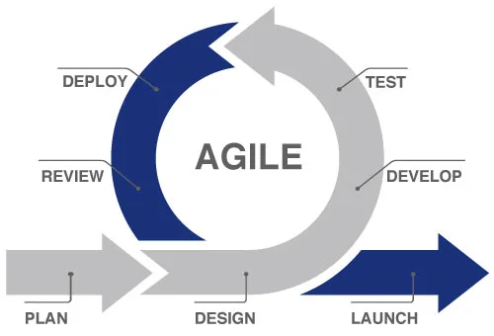

**Figure 2. SDLC Agile Model**

**Plan.** First of all, the researchers planned what they wanted to achieve and also determined the project itself. They got to experience the drawbacks of the recruitment process, and when it came to recruiting, they organized their website that could better the process.

**Design.**

Next, they design or formulated the only meaning of the site and the way it needs to be working. They figured out which and how many features have, and how the information should be ordered.

**Develop.** After that, they realized using an Agile methodology when they began building the site. Each portion of the work was then divided by them and they kept on working it better and better.

**Test.** After that, they followed this action with inspecting whether there was nothing amiss. They pushed to see if the system were working, if the website appeared nicely on various devices and fixed any mistakes they once discovered.

**Deploy.** Then after everything was functioning well, they launched the website or system, on the internet. They could be nice to them but also make sure everything was all right.

**Review.** The system underwent a review phase where it was evaluated for its effectiveness and they have comment to taste the pale and to inquire them about their feedback. The way it is was that they needed to ensure that it served everyone equally well.

**Launch.** The system was reviewed, approved, and finally launched. It became active to the insurance and investment entities in MIMAROPA wherein the system was now accessible by these agencies. On the last step, everything was checked twice: pictures looked great, the language was nearly perfect, and the site was finally launched for everyone to use. They taught the people what they would borrow and made it simple for them.

**Gantt Chart**

The Gantt Chart in this section presents the details of the planning and time schedules of the project. The schematic of the project has all the development stages from planning up to the accomplishment mapped in this chart.

|  |  |  |  |  |  |  |  |  |  |  |  |  |  |  |  |  |  |  |  |  |
| --- | --- | --- | --- | --- | --- | --- | --- | --- | --- | --- | --- | --- | --- | --- | --- | --- | --- | --- | --- | --- |
| **Table 1. Gantt Chart** | | | | | | | | | | | | | | | | | | | | |
| **Task Name** | **Task Date** | | | | | | | | | | | | | | | | | | | |
| Nov | | | | Dec | | | | Jan | | | | Feb | | | | Mar | | | |
| Week 1 | Week 2 | Week 3 | Week 4 | Week 1 | Week 2 | Week 3 | Week 4 | Week 1 | Week 2 | Week 3 | Week 4 | Week 1 | Week 2 | Week 3 | Week 4 | Week 1 | Week 2 | Week 3 | Week 4 |
| **1.Planning** |  |  |  |  |  |  |  |  |  |  |  |  |  |  |  |  |  |  |  |  |
| 1.1 Conduct an interview |  |  |  |  |  |  |  |  |  |  |  |  |  |  |  |  |  |  |  |  |
| 1.2 Define project objectives |  |  |  |  |  |  |  |  |  |  |  |  |  |  |  |  |  |  |  |  |
| 1.3 Define project plan |  |  |  |  |  |  |  |  |  |  |  |  |  |  |  |  |  |  |  |  |
| 1.4 Approval of project plan |  |  |  |  |  |  |  |  |  |  |  |  |  |  |  |  |  |  |  |  |
| 1.1 Data Collection |  |  |  |  |  |  |  |  |  |  |  |  |  |  |  |  |  |  |  |  |
| 1.2 Functional |  |  |  |  |  |  |  |  |  |  |  |  |  |  |  |  |  |  |  |  |
| 1.3 Non-Functional |  |  |  |  |  |  |  |  |  |  |  |  |  |  |  |  |  |  |  |  |
| **2.Design** |  |  |  |  |  |  |  |  |  |  |  |  |  |  |  |  |  |  |  |  |
| 2.1 Frontend software design |  |  |  |  |  |  |  |  |  |  |  |  |  |  |  |  |  |  |  |  |
| **3.Development** |  |  |  |  |  |  |  |  |  |  |  |  |  |  |  |  |  |  |  |  |
| 3.1 Back-end coding |  |  |  |  |  |  |  |  |  |  |  |  |  |  |  |  |  |  |  |  |
| 3.2 Front-end coding |  |  |  |  |  |  |  |  |  |  |  |  |  |  |  |  |  |  |  |  |
| **4.Testing** |  |  |  |  |  |  |  |  |  |  |  |  |  |  |  |  |  |  |  |  |
| 4.1 Functionality testing |  |  |  |  |  |  |  |  |  |  |  |  |  |  |  |  |  |  |  |  |
| 4.2 User interface testing |  |  |  |  |  |  |  |  |  |  |  |  |  |  |  |  |  |  |  |  |
|  | | | | | | | | | | |  |  |  |  |  |  |  |  |  |  |
| **Legends:** |  | | | | **Done** | | | | | |  |  |  |  |  |  |  |  |  |  |

**Requirements Specifications**

The requirements specifications for the online recruitment system include the functional requirements, user interface, software interface, hardware interface, and security interface. The specs highlight the required functions, connection points, and security components that the system needs to be able so as to be made dependable and also safe.

**Functional Requirements**

The functional requirements will determine the system performance, highlight the actions that must be taken and suggest the policies needed for the system being done effectively. With such good exposure, the system and the data tail leading to work outputs are demonstrated which involves the presentation of the system. The fact is that researcher need to have the system talk with the team members' directly where the personnel should up-to-date the functioning requirements and validate the system by making sure it as responding to what exactly had the request.

**Table 2. Functional Requirements**

|  |  |
| --- | --- |
| **Features** | **Description** |
| 1. User Authentication | Apply secure user authentication for admin, agents, and applicants. Account creation, login, and resetting password. |
| 2. Administrator Dashboard | Develop a dashboard for administrator to visually monitor user activity, agent and applicant data, and recruitment metrics. |
| 3. Data Management | Enable administrator to view, manage, and add agent accounts, implement a review process for applicant data, and facilitate data transfer to agents. |
| 4. Overview Display | Provide administrator with an overview feature displaying the total number of agents, applicants, and relevant recruitment data. |
| 5. Profile Management | Allows administrator, agents, and applicants to manage personal information and account settings. |
| 6. Document Handling | Enable administrators to download applicant forms and documents as PDF files for record-keeping. |
| 7. Integrated Messaging | Facilitate communication between admin, applicants and agents through the integrated messaging system. |
| 8. Notification System | Notification systems to notify admin of new messages, incoming applicants, and other activity. |
| 9. Search and Filtering | Search and filtering to help admin easily find information about agents and applicants. |
| 10. Employee Recruitment Dashboard | Create employee dashboards to visually track user metrics and performance data. |
| 11. Secure Data Viewing | Enable agents to securely view personal information, application forms, and status of recruited applicants. |
| 12. Account Management for Agents | Giving an access for agents to manage their account like profile information and changes when it comes to their password. |
| 13. Online Application Form | Provide a form in online for applicants to fill out personal and professional information. |
| 14. Document Upload | Allow applicants to upload documents and any images for their application. |
| 15. Financial Adviser Selection | Enable applicants to browse and select an agent from a list of available FAs. |
| 16. Application Save and Modify | Allow applicants to save their work and return to the application later for modifications. |
| 17. Submission Mechanism | Provide a submission mechanism for applicants to formally submit their completed application to the system. |

Table 2 shows that the E-Recruitment: An Online Recruitment System for Insurance and Investment Agency in MIMAROPA features consists of user authentication, administrator dashboard, data management, overview display, profile management, document handling, integrated messaging, notification system, and search and filtering.

**User Interface**

The user interface happens to be the main element in online recruitment as it supports interactions between the systems and the user. The user interface should be so designed as if it is easy to use and friend ties to a user with an appealing look. System should be presented in a simple and understandable way highlighting its i.e. functions.

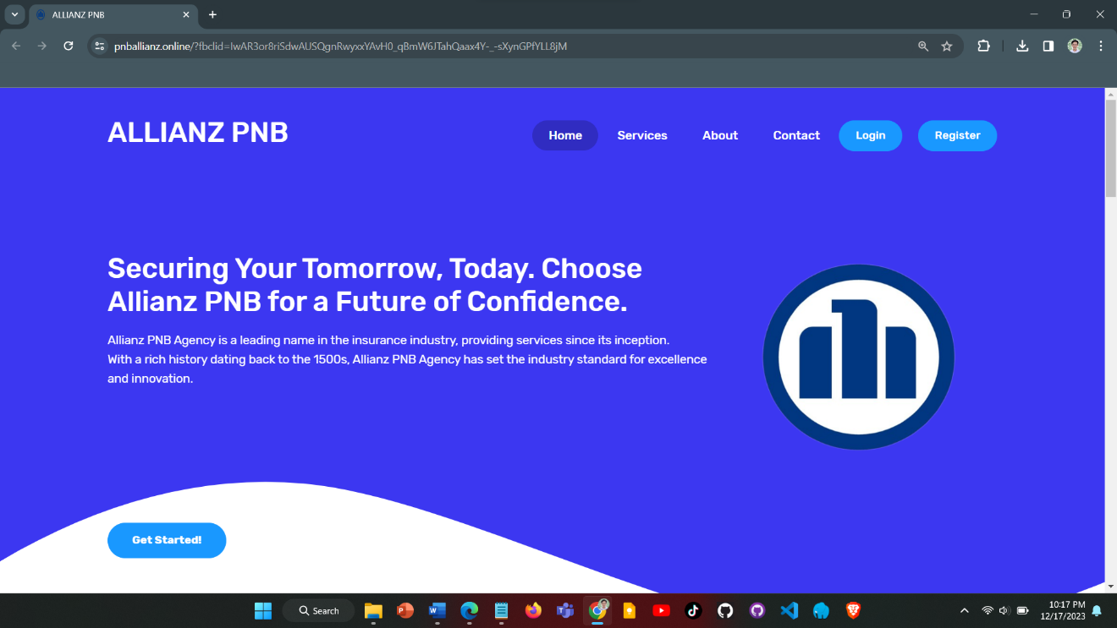

**Figure 3. User Interface**

**Hardware Interface**

The hardware interface defines the logical and physical composition of the interface between the software and hardware components. The it specifies the hardware components and their parameters to ensure that the system operates successfully. Enumeration covers the actuators, the processor, 16 GB RAM memory, the 256GB SSD storage, and network architecture.

**Software Interface**

The user interface will establish the current windows 8 to 11 operating system used, the database or other databases, external tools and libraries the system will utilize, and the built-in commercial components which will support the system. It encompasses specifics about the software programs and their respective versions that were employed in system design and testing.

**Security Requirements**

Security measures are among factor of major importance in order to keep the system is available and the private data is protected only by authorized users only. Security requirements shall conform to data protection and recruitment registration procedures so that the system and the data of the system remains confidential, integral and available.

**Technical Background**

An outlook section that is directed towards the technical aspects of the project gives the technical background by detailing inventories of hardware and software. This data gives the specific/detailed definition of an entity in an easy-understandable manner for the developers. It covers the information concerning the names of the hardware components, the operating system, the programming languages, frameworks and the tools used in the system build and deployment for online recruitment.

**Hardware Specifications**

Hardware Specifications means technical descriptions of hardware items, their components and functions. Consideration of the hardware elements which will ensure the efficiency and functionality of the project is a must. The table below presents the different hardware components and their recommended specifications:

**Table 3. Hardware Specification**

|  |  |  |  |  |  |
| --- | --- | --- | --- | --- | --- |
| **Hardware** | **Function** | | **Specifications** | | **Unit** |
| **Minimum** | **Recommended** |
| CPU and Memory | | Efficient handling of loads | At least 16GB RAM | At least 16GB RAM | 1 |
| Storage | | Faster data access | 256GB SSD | 512GB SSD | 1 |
| Network Infrastructure | | Reliable and high-speed internet connectivity | Integrated dedicated 4G LTE modem | Integrated dedicated 4G LTE modem | N/A |
| Laptop | | Development workstation with connectivity | Intel Core i5 processor, 16GB DDR4 RAM, 256GB SSD, | Intel Core i5 processor, 16GB DDR4 RAM, 512GB SSD, | 1 |

**Software Specifications**

Software Specifications are of vital importance for the correct mobilization and connectivity of the online recruitment system. The table below presents the minimum and recommended specifications for various software components:

**Table 4. Software Specification**

|  |  |  |
| --- | --- | --- |
| **Component** | **Minimum**  **Specifications** | **Recommended**  **Specifications** |
| Operating System | Windows 8 64 bit | Windows 10 or Latest |
| Code Igniter | CodeIgniter 4.0 | CodeIgniter 5 or newer |
| Visual Studio Code | Visual Studio Code 1.40 | Visual Studio Code 1.50.1 or Latest |
| Web Browser | Google Chrome | Google Chrome or Any Web Browser |
| Web Server | Laragon 4.0.16 | Laragon 6.0 |
| Web Hosting | Hostinger | Hostinger |
| Database  (phpMyAdmin) | 1 Database | 2-3 Available Databases |
| MySQL | 5.1 | 5.6 or Latest |

As shown on the Table (number), it outlines the minimum and recommended specifications for various software components required for the online recruitment system. It consists of a set of explanations such as this is about the operating system, Code Igniter framework, Visual Studio Code, web browser, web server, web hosting as well as database. By defining these software specs, the online recruitment platform is able to work with necessary software pieces and perform the intended function.

**System Analysis and Design**

In the analysis and design of the system, I determined the requirements, developed diagrams of the major components and their functions, and provided directions for the development and deployment of the online recruitment system.

**System Overview**

The “E-Recruit: An Online Recruitment System for Insurance and Investment Agency in MIMAROPA” is a web-based platform made specially for the insurance and investment agencies operating in MIMAROPA in the Philippines. It is designed to learn the hiring process from the applicant's side, and enhance the whole candidate's experience of this. The system enables the applicants to register and log in to their personal accounts; to file out their applications and to submit their data directly to that administrator. The administrator examines the information and consequently confirms or reject their application. Assuming that the applicant is endorsed, the administrator inputs their status and sends a message to the applicant. The screening and filing system, therefore, have been complimented by the process which provide notification and reminders hence the smooth and quick recruitment. The system of architecture and design was designed with meticulous planning and the implementation being equally exhaustive and huge with its own technological problems. The system has been tested in the field and of course researcher follow all the necessary scrupulous procedures to establish the accuracy, the performance, and the quality of the output. It works on servers or hosting platforms that conforms to the agency and the applicant network to be able to access. Besides that, it employs data-based hiring scores that are generated by using data analysis and evaluation in a bid to give the candidates who consider a hire quality experience. The aim of the system is to guarantee ease and speed of the recruitment process; it has been designed to be friendly to the users including the applicants.

**System Architecture**

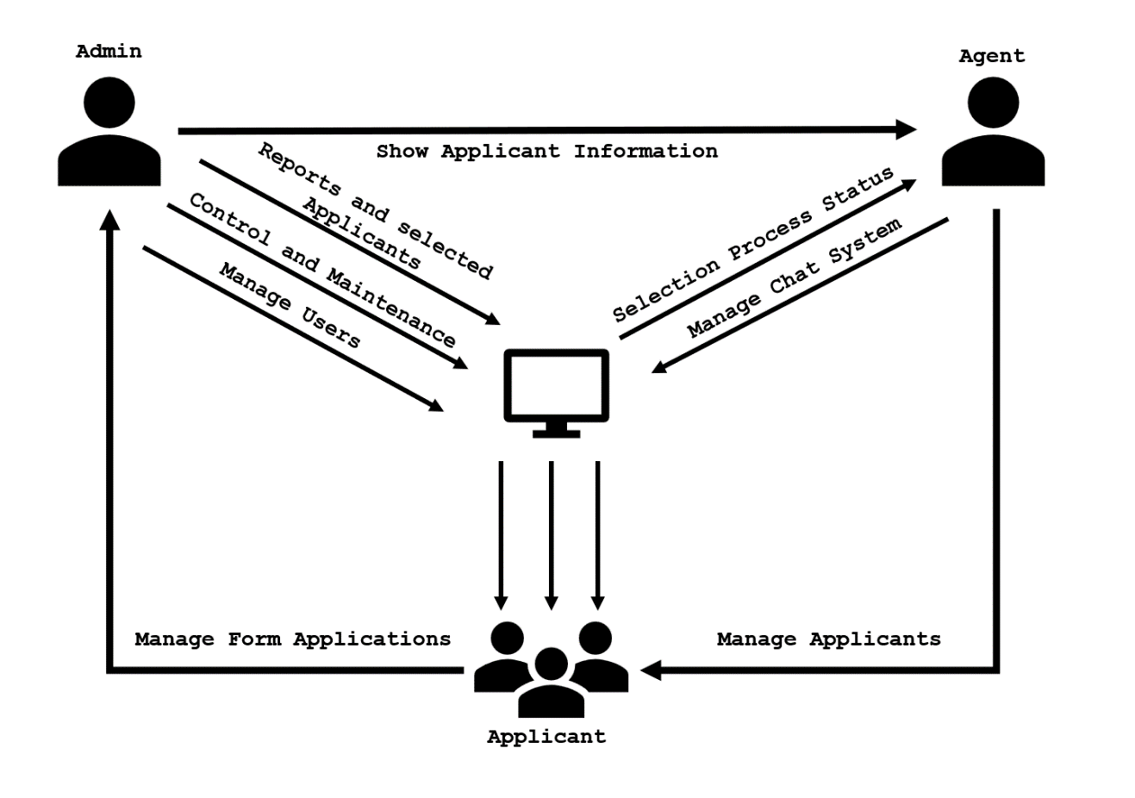A system architecture shows the representation and structure of the system.

**Figure 4. System Architecture**

This figure shows that the admin is in charge of working by requesting display of a candidate information, catering for varied components such as the reports, the selections of candidates, the control and maintenance, and the user management. Follows that way, the Agent acts as an intermediary between candidates and the System which enables to keep them informed concerning the selection process status. However, the User interacts with the system to handle their forms. System is a hub which is between established communication channels between Admin, Agents, and Applicants. It is the one that updates the selection processes for Agents, and Forms Admins’ requests for reports and applicant management, thus facilitating and organizing in general all functions of the application management system.

**Use Case Diagram**

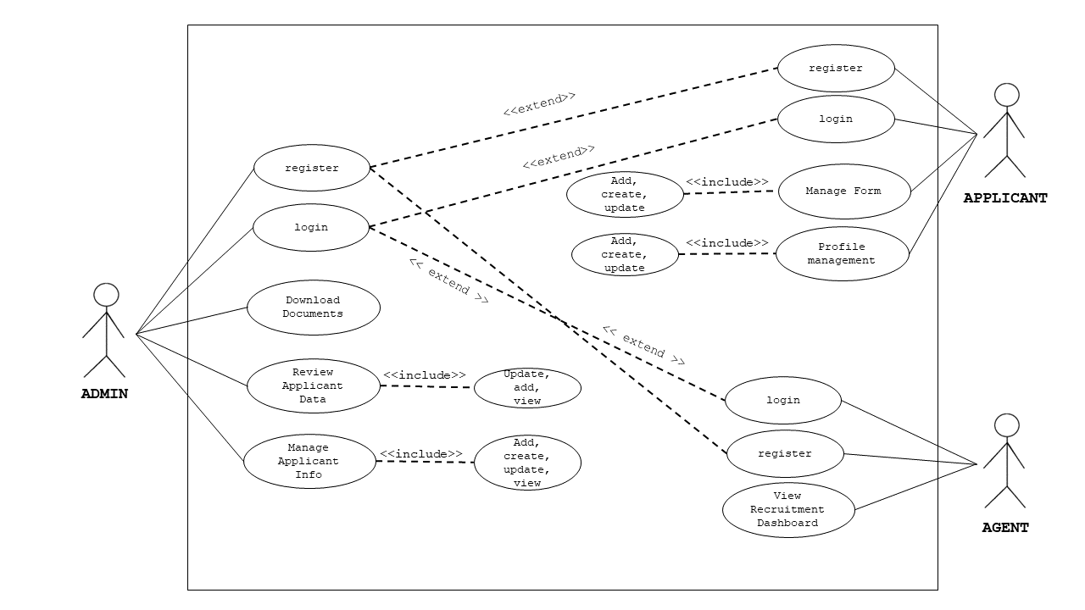This illustration serves as an outline of how these stakeholders all interact with and complement each other in carrying out functions within the system. The more researcher get into the details of this chart, the better understand what responsibility each role has and how it is related to other roles, giving insight on how all these pieces fit together in a system that works smoothly across an entire organization.

**Figure 5. UML Use-case Diagram**

Figure 3 shows the roles of the Administrator, Agent, and the Applicants to be executed in the whole process of the system.

**Activity Diagram**

This part of the document presents the flow of the project using an object-oriented flowchart. Its purpose is to capture the dynamic behavior of the system. It focuses on the execution and flow of the behavior of a system instead of implementation.

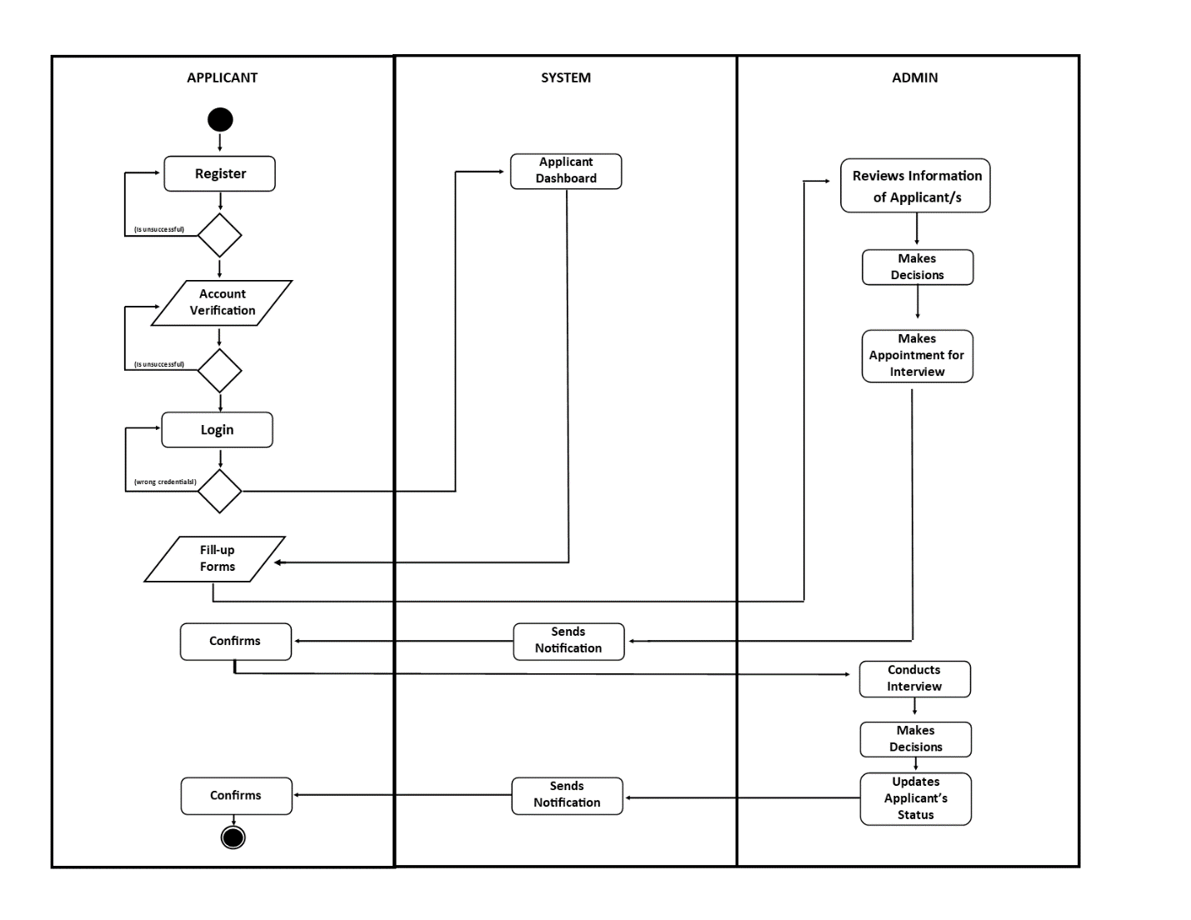

**Figure 6. Activity Diagram**

Figure (number) shows, the activity diagram of the system wherein the applicants will register then login their accounts and they will fill-up the forms and the information will be sent directly to the administrator. The administrator will then review their information and makes the decision if the applicant is valid for interview, the administrator will make an appointment and then the system will notify the applicant for the interview and the applicant will confirm it. The administrator will then conduct the interview, after the interview the administrator will again decide if the applicant is good for the job, if the applicant is accepted, the administrator will update the applicant’s status, the system will send the notification to the applicant and the applicant will confirm it.

**Data Flow Diagram**

The data flow diagram, which functions similarly to a map to depict the information flow for all system processes, is presented next.

**Figure 7. Context Diagram**

The figure 7 shows how the system will be developed concerning the different fields in which they are part for specification into the users that will make use of it.

**Diagram 0**

The Diagram 0 of E-Recruit: An Online Recruitment System for Insurance and Investment Agency in MIMAROPA shows the flow of information to visualize the process of the project.

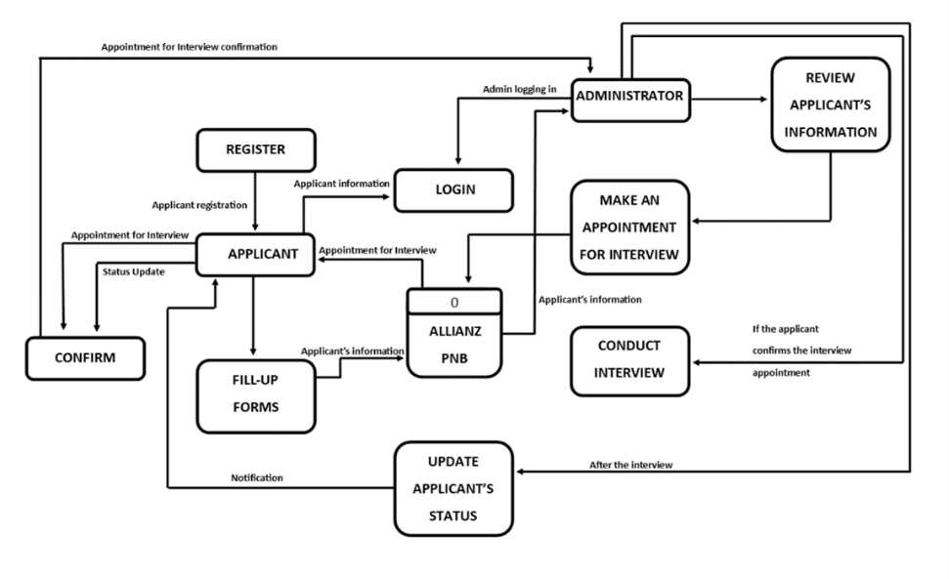

**Figure 8: DFD Level 0**

Figure 8: DFD Level 0 illustrates the interactions and data flows between the Admin, Agents, and Applicants.

**Database Schema**

The design of the system turned out to be the most crucial in the projects development. At this stage, the system's entity’s traits were described, mostly in relation to definitions. This made it simply for the user to assess and understand the properties which came with these existing things. The system design phase allowed the detailed description of the dataset of the study. The entities were revealed and the features were exhibited.

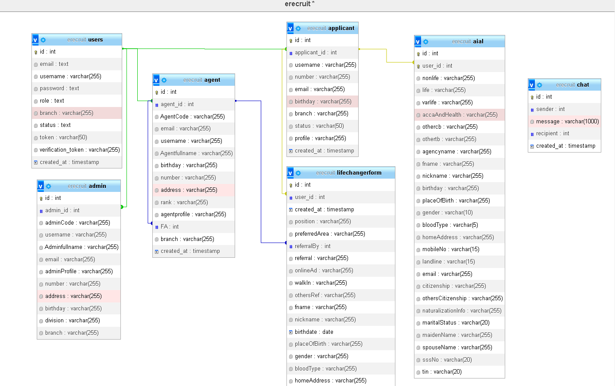

**Figure 9. Databased schema**

Here is a diagram entailing the structure of the E-recruitment database in which all basic tables are connected with primary and foreign keys that are fully responsible for establishing the relationship between them. The primary keys are unique identifiers for each user or record stored in the table, at the same time foreign keys are used to link data tables by referencing the primary key of another table. The scheme of the database draws a picture of the tables structure and how related tables are linked, hence making data manipulation and maintenance efficient while also allowing maintenance of data consistency and accuracy.

**Testing and Evaluation**

This period affords researcher the best time for system testing and complete mounting to ensure maximum functionality. Researcher enhance the system's ability of providing whole of service spectrum by several improvements. Researcher are persistently striving for better as we attribute great importance to upgrading the system up to the level of maximum functionality and convenience. The critical thing that relies on here is being properly and rapidly entirely quality control program. This is the place that clients get to tell how much individuals behind the creation and development of a site have concentrated or vibrated to make the site more friendly.

**Participants of the Study**

The respondents to the study were composed of the administrator, applicants, agents.

**Table 5. Respondents of the Study**

|  |  |
| --- | --- |
| **Respondents** | **Number of respondents** |
| Administrator | 1 |
| Applicants | 39 |
| Agents | 20 |
| **Total** | **60** |

Table 5 shows the respondents of the study, including the number of each category respondents

**Data Gathering Instrument**

The respondent to the study took part in the survey through the use of the questionnaires which had been provided for them by the researchers. The respondent's collected data would be verified to help in knowing the kind of information which people want to access in the website. Rating scale questionnaire were used by the researchers as tool, Likert scale being a method was applied to collect data from the respondents.

**Table 6. Linker Scale-type**

|  |  |  |
| --- | --- | --- |
| **Scale** | **Range** | **Verbal Interpretation** |
| 5 | 4.51-5.00 | Strongly Agree |
| 4 | 3.51-4.50 | Agree |
| 3 | 2.51-3.50 | Moderate Agree |
| 2 | 1.51-2.50 | Disagree |
| 1 | 1.00-1.50 | Strongly Disagree |

**Implementation Plan**

The system developed by the researchers will begin to attract people, and strategy for implementation will also be proposed. Sule wants to explore the possibility that he is also born again along with the system and accordingly the documentation will be handed over. It will cover from how to apply the system updates, which one has to oversee, to maintenance. The letter should be agreement that the system is given unreservedly to the user starting from this moment and that researchers won’t take responsibility for updating and system maintenance. In the case of the referendum being positive the researchers would like to have various strategies involved.

**Table 7. Implementation Plan**

|  |  |  |
| --- | --- | --- |
| **Activities** | **Date** | **Progress Note** |
| Meeting with the Client | November 5, 2023 | Agreed in the Project Proposal |
| Deployment Approval | March 7, 2024 | Approved |
| System Deployment and Monitoring Period | March 30, 2024 | Few errors and updates on the major features |
| System Evaluation | May 15, 2024 | Client was satisfied |

s

**REFERENCES**

Aljuaid, A. (2021). *Artificial Intelligence Based E-Recruitments System: A Case Study on Recruiters of Bangladesh*.

Bhosale, C., & Gurav, P. (2021). *Employee Recruitment System: Analysing the Effectiveness of Online Recruitment*. www.ijrpr.com

Blumenberg, C., Menezes, A. M. B., Gonçalves, H., Assunção, M. C. F., Wehrmeister, F. C., & Barros, A. J. D. (2019). How different online recruitment methods impact on recruitment rates for the web-based coortesnaweb project: A randomised trial. *BMC Medical Research Methodology*, *19*(1), 1–9. <https://doi.org/10.1186/s12874-019-0767-z>

Chuks Okolie, U., & Irabor, I. (2019). *E-Recruitment: Practices, Opportunities and Challenges. The changing face of recruitment and selection in human resource management.*

*DOLE readies department order governing online recruitment platforms*. (n.d.). Retrieved December 5, 2023, from <https://www.cnnphilippines.com/news/2020/5/29/DOLE-readies-department-order-governing-online-recruitment-platforms.html>

Edirisinghe, S. M. (2020). *Recruitment Management System*. <https://dl.ucsc.cmb.ac.lk/jspui/bitstream/123456789/4486/1/2017%20MIT%20017.pdf>

Grace, M., Ventura, G., & Bringula, R. P. (201920). *Effectiveness of Online Job Recruitment System: Evidence from the University of the East*. www.IJCSI.org

Hotwani, S., & Chandure, O. (2019). STUDY PAPER ON E-RECRUITMENT. In *Internatio nal Journal of Research In Science & Engineering e*.

Ho, D., & Henry, A. (2021). Constraints imposed on the creative cover letter writing by digital online job advertisements. *Australian Journal of Applied Linguistics*, *4*(3), 132–148. <https://doi.org/10.29140/ajal.v4n3.513>

*Job hunt tough for graduates of ‘pandemic generation’ Inquirer News*. (n.d.). Retrieved December 5, 2023, from <https://newsinfo.inquirer.net/1755172/job-hunt-tough-for-graduates-of-pandemic-generation>

*Jobs recovery seen as market reopens | Philippine News Agency*. (n.d.). Retrieved December 5, 2023, from <https://www.pna.gov.ph/index.php/articles/1166432>

Karaoglu, G., Hargittai, E., & Nguyen, M. H. (2022). Inequality in online job searching in the age of social media. *Information Communication and Society*, *25*(12), 1826–1844. <https://doi.org/10.1080/1369118X.2021.1897150>

Kmail, A. B., Maree, M., Belkhatir, M., & Alhashmi, S. M. (2016). An automatic online recruitment system based on exploiting multiple semantic resources and concept-relatedness measures. *Proceedings - International Conference on Tools with Artificial Intelligence, ICTAI*, *2016*-*January*, 620–627. <https://doi.org/10.1109/ICTAI.2015.95>

Intelligence: Online Hiring in Philippines Increases Fifteen Percent in 2019 Q4, Shows Study by Job Search Platform Monster. (2019). Intelligence: Online Hiring in Philippines Increases Fifteen Percent in 2019 Q4, Shows Study by Job Search Platform Monster. <https://www.adobomagazine.com/philippine-news/intelligence-online-hiring-in-philippines-increases-fifteen-percent-in-2019-q4-shows-study-by-job-search-platform-monster/>

Lee, L., Guzzo, R. F., Madera, J. M., & Guchait, P. (2021). Examining Applicant Online Recruitment: The Use of Fictitious Websites in Experimental Studies. *Cornell Hospitality Quarterly*, *62*(1), 76–88. <https://doi.org/10.1177/1938965520965223>

Malki, Z., Atlam, E., Malki, Z., & Atlam, E. (2021). Graduate Students and Companies Web Based E-Recruitment System. *Journal of Computer and Communications*, *9*(9), 71–84. https://doi.org/10.4236/JCC.2021.99005

Moseson, H., Kumar, S., & Juusola, J. L. (2020). Comparison of study samples recruited with virtual versus traditional recruitment methods. *Contemporary Clinical Trials Communications*, *19*, 100590. <https://doi.org/10.1016/j.conctc.2020.100590>

*Most PH job seekers now prefer hybrid, remote work setup | Inquirer News*. (n.d.). Retrieved December 5, 2023, from <https://newsinfo.inquirer.net/1737214/most-ph-job-seekers-now-prefer-hybrid-work-setup>

Obipi , I. O., & Kalio, N. (2018). Recruitment Management System and Employee Procurement in the Oil and Gas Sector in Nigeria. *International Journal of Human Resource Management and Research*, *8*(2), 7–18. https://doi.org/10.24247/ijhrmrapr20182

*Online recruitment seen to remain positive | Philstar.com*. (n.d.). Retrieved December 5, 2023, from <https://www.philstar.com/business/2018/06/24/1827269/online-recruitment-seen-remain-positive>

*Philippines: Recruitment agencies and lenders allegedly collude to exploit migrant workers, amid lack of govt. action to tackle abuse. (2023, December 5).* [*https://www.business-humanrights.org/en/latest-news/philippines-recruitment-agencies-and-lenders-collude-to-exploit-migrant-workers-amid-lack-of-govt-action-to-tackle-abuse/*](https://www.business-humanrights.org/en/latest-news/philippines-recruitment-agencies-and-lenders-collude-to-exploit-migrant-workers-amid-lack-of-govt-action-to-tackle-abuse/)

Prasetyaningtyas, S. W., Sim, M., Triantoro, B. H., & Allen, A. (2022). THE USE OF EMPLOYER BRANDING DIMENSIONS TO ATTRACT FRESH GRADUATES. *Jurnal Bisnis Dan Manajemen*, *23*(1), 3–15. <https://doi.org/10.24198/JBM.V23I1.891>

Ramadhani, F., & Zarlis, M. (n.d.). *Analysis of e-Recruitment System Design*. https://doi.org/10.17706/ijeeee.2019.9.1.38-45

Ronaldo  A. Manalo, Chin  Uy, & Jun  R. Grimaldo. (2020). UTILIZATION OF E-RECRUITMENT TOOLS AS PERCEIVED BY RECRUITERS AND JOB APPLICANTS. *Luz y Saber*, *14*(1 and 2), 1–1. <https://ejournals.ph/article.php?id=17160>

Rosoiu, O., & Popescu, C. (n.d.). *E-recruiting Platforms: Features that Influence the Efficiency of Online Recruitment Systems*. https://doi.org/10.12948/issn14531305/20.2.2016.05

Samoli, C. (2021, May 20). *How management systems drive value in business operations*. Monday.com Blog. https://monday.com/blog/project-management/management-systems/

Sehgal, V. K., Jagtiani, A., Shah, M., Sharma, A., Jaiswal, A., & Mehta, D. (2018). Job portal-A web application for geographically distributed multiple clients. *Proceedings - 1st International Conference on Artificial Intelligence, Modelling and Simulation, AIMS*, 199–204. <https://doi.org/10.1109/AIMS.38>

Shendage, S., Shinde, T., Govilkar, K., & Chavan, J. (2019). Issue 6 www.jetir.org (ISSN-2349-5162). *JETIR1906B57 Journal of Emerging Technologies and Innovative Research*, *6*.

|  |
| --- |
| **Checked and Reviewed by:** |
|  |
| **Mr. Christian I. Cabrera** |
| **ITC311 - Facilitator** |